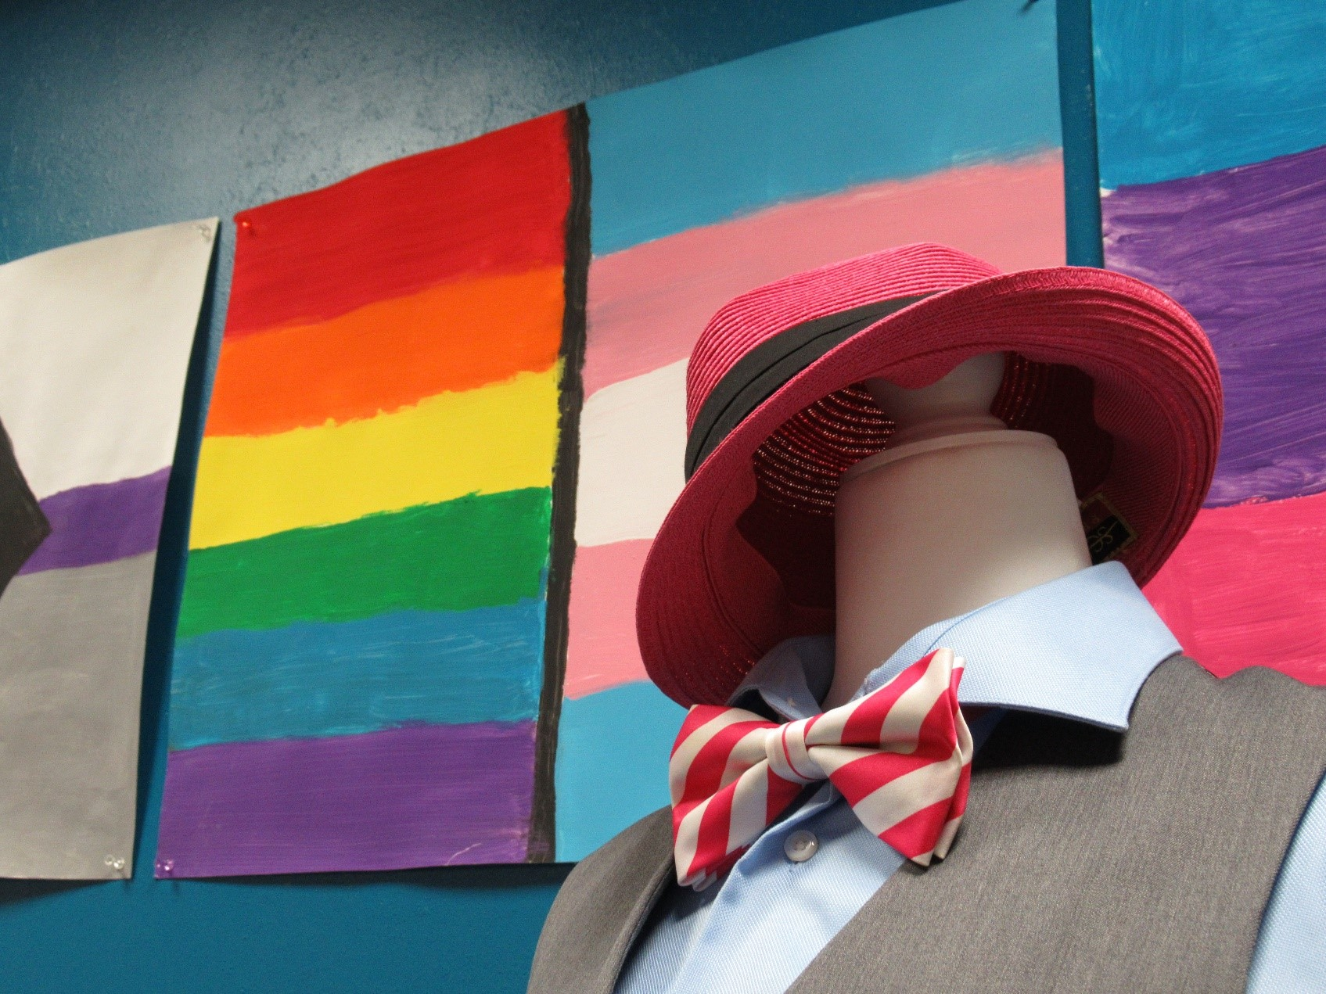

Teens ages 13 to 19 are invited to find the perfect outfit for prom.

With the help of community donations, we are giving away gently used formal wear including dresses, suits, shoes, accessories, and other attire.

A few tips before you come “shop” with us:

* Clothes may be tried on, but please wear under-clothing that makes it easy to change (e.g. sports bras, leotards) as there will be limited privacy.
* Please don’t wear makeup when trying on items. It can get on clothing and ruin them.
* Adults are welcome to accompany teens, but teens are the only ones who may take items home.

***Robbie Waters Pocket-Greenhaven Library***

7335 Gloria Drive, Sacramento

Thursday, March 6th starting at 2pm

Prom Drive Giveaway